Tutorial – 7

**Aim:** Display calendar of current month; Display today’s date and time; Display usernames those are currently logged in the system; Display your name at given x, y position; Display the terminal number.

**Code:**#!/bin/bash

echo -e "Current month: \c"

date "+%B %Y"

echo -e "Today's date and time: \c"

date

echo -e "Usernames currently logged in: "

who | cut -d' ' -f1 | sort | uniq

echo -e "Terminal number: \c"

echo $TERM

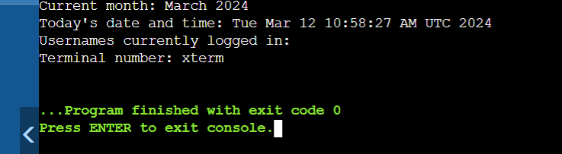**Output:**